**SAI VARUN THABETI**

**700741122**

**ASSIGNMENT 5**

**NEURAL NETWORKS AND DEEP LEARNING**

1. Implement Naïve Bayes method using scikit-learn library

Use dataset available with name glass

Use train_test_split to create training and testing part

Evaluate the model on test part using score and

classification_report(y_true, y_pred)

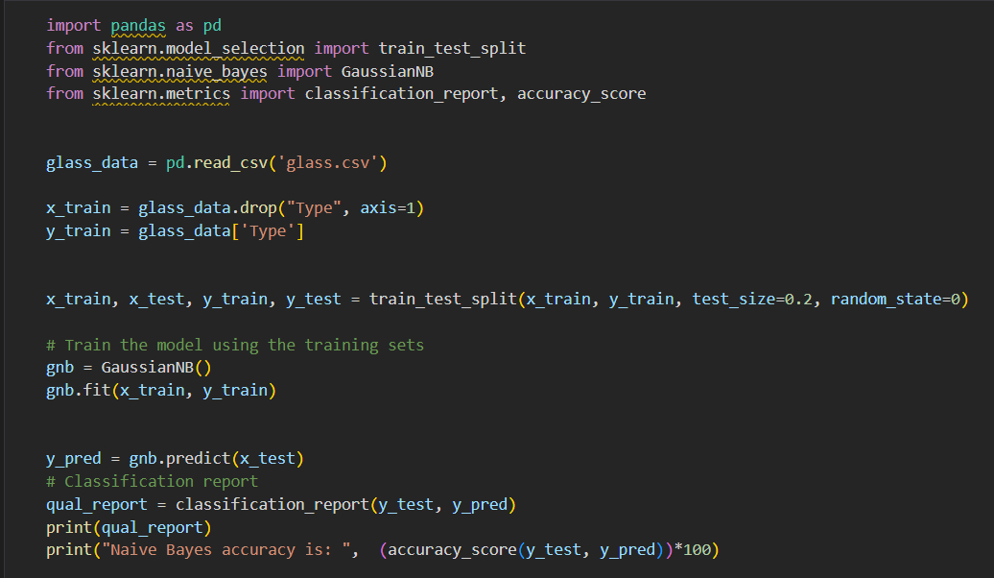

1. Implement linear SVM method using scikit library

Use the same dataset above

Use train_test_split to create training and testing part

Evaluate the model on test part using score and classification_report(y_true, y_pred)

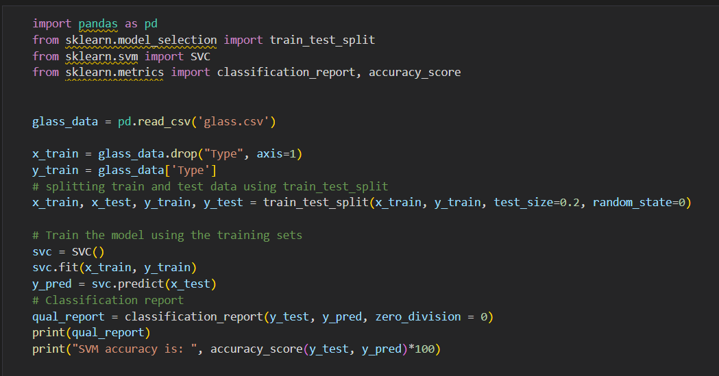

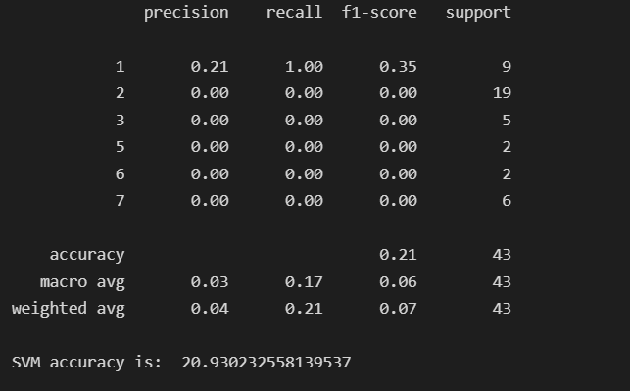

Which algorithm you got better accuracy? Can you justify why?

Gaussian algorithm gives better accuracy. As the accuracy we got upon training on gaussian is

greater than that of SVM.